논문제목 (HY신명조, 20pt)

First Author¹, Second Author², and Third Author¹
¹Department of Aerospace Engineering, XXXXX University, Seoul, South Korea
²Department of Electronic Engineering, OOOO University, Seoul, South Korea

Abstract – Abstract of the paper (HY신명조, Bold, 10pt) * Do Not Use Symbols, Special Characters, Footnotes, or Math in Paper Title or Abstract.
Keywords – Keywords of the paper (HY신명조, Bold, Italic, 10pt)

Introduction (HY신명조, 10pt)
This is the introduction of the paper. (HY신명조, 10pt)

Section (HY신명조, 10pt)

Subsection (HY신명조, Italic, 10pt)
This is the subsection of the paper. (HY신명조, 10pt)
Equations are shown below.
a + b = λ (1)
c + d = δ (2)

Subsection (HY신명조, Italic, 10pt)
This is the subsection of the paper. (HY신명조, 10pt)
Items are shown below.
- The word “data” is plural, not singular.
- The subscript for the permeability of vacuum μ₀, and other common scientific constants, is zero with subscript formatting, not a lowercase letter “o”.
- Commas, semicolons, periods, question and exclamation marks are located within quotation marks only when a complete thought or name is cited, such as a title or full quotation.
- When quotation marks are used, instead of a bold or italic typeface, to highlight a word or phrase, punctuation should appear outside of the quotation marks.
- A parenthetical phrase or statement at the end of a sentence is punctuated outside of the closing parenthesis (like this).

Subsection (HY신명조, Italic, 10pt)
This is the subsection of the paper. (HY신명조, 10pt)

Table is shown below.
- Table Type Styles
Table Head | Table Column Head
Table Head | Table column subhead | Subhead | Subhead
copy | More table copyª

Figure is shown below.
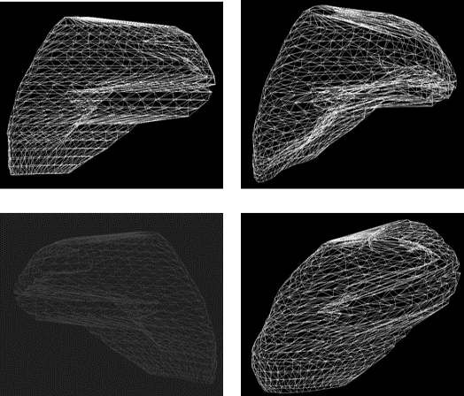
- Example of a figure caption

Conclusion (HY신명조, 10pt)
This is the conclusion of the paper. (HY신명조, 10pt)

Acknowledgment (HY신명조, 10pt)
This is the acknowledgment of the paper. (HY신명조, 10pt)

References (HY신명조, 10pt)
- K. Elissa, “Title of paper if known,” unpublished.
- R. Nicole, “Title of paper with only first word capitalized,” J. Name Stand. Abbrev., in pres

